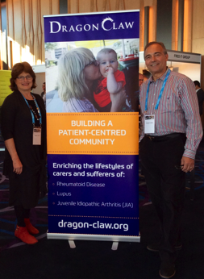

Over July and August life living with the dragon was been hectic. We are going through the legal and administrative processes to become a full charity under Australian law. This is quite a big deal and has proved to be much more work than we anticipated.

Building the website has required the directors to learn a new software platform Joomla, assemble loads of material and generally get confused. Luckily we have a guide and mentor.

A group of four members have been developing our social media presence on LinkedIn and on Facebook. These are now up so look for Dragon Claw.

Dragon Claw volunteers successfully ran an information booth at the national conference of pharmacists meeting in Sydney. We were impressed by the good will from all who visited and a number of useful introductions were made. As this was our first non-speaking conference event we needed to develop a large banner, which has been well received (above, next column).

**Dr. Daniel Lewis**

We are very pleased to welcome Dr. Daniel Lewis to Dragon Claw as our clinical advisor. Daniel is an experienced rheumatologist and pain physician who integrates mainstream medicine with natural approaches to health and wellbeing. He has a private specialist medical practice in Melbourne. Daniel’s passion is integrating balanced lifestyle practices into the mainstream management of bone, joint and arthritis-related disorders.

The Lewis Institute for Health and Wellbeing evolved out of Daniel’s desire to provide a supportive and empowering educational network for individuals with long-term arthritis, fibromyalgia, chronic fatigue, pain - and other health-related illnesses and for those wishing to prevent illness. You can visit the Institute at ([www.pathways2wellbeing.com.au](http://www.pathways2wellbeing.com.au))

The Resources section of our website now includes a link to the Institute.

**Member Shirt Design**

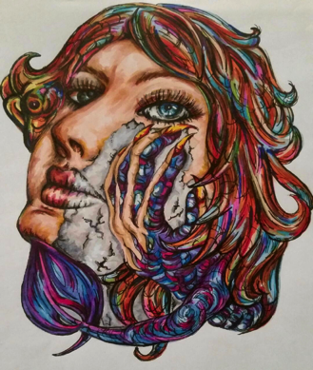

Did you know its World Arthritis Day on October 12th? Show your support by purchasing a t-shirt image designed by Dragon Claw member Jo. We're targeting a Men's and a Women's style for $35 + GST and postage.  Email your expression of interest to [susanresumes@bigpond.com](mailto:susanresumes@bigpond.com) by September 15 and we'll send you more information once all the responses have been compiled.

August

Issue 21

Some Self Evaluation



[www.dragon-claw.org](http://www.dragon-claw.org)

**Rheumatoid Disease Self Care**

STOP PRESS! **We are thrilled to have the support of Baker & McKenzie, a globally leading legal firm.**

**Your Gut Bugs**

You may have noticed an increasing interest by the media with all the research about bacteria in our small and large intestines. The ABC and SBS have had two specials on the subject. Not to crow (!) but Dragon Claw has included material on the same subject for over two years now. We have two very detailed videos on the subject. Just click the video button when you login.

**Stress and Isolation**

A full time mother of three who also works three days a week called about her concerns after discovering Dragon Claw. Sudden onset rheumatoid disease has left her floundering for support. Her concerns focus on “no one understands because I look OK”, poor communication with her specialist and persistent worries about the future. These three issues break down to a myriad of other issues and associated concerns. Talking to someone with the disease that understands makes a world of difference. It also confirms that she is not alone. One of our future plans for Dragon Claw is to run online discussion groups. If you are worried and anxious perhaps visit the Mental Health section of our website. There is a self-assessment test there that may get you thinking.

**Pfizer** **Australia**

Dragon Claw is working with Pfizer Australia as they seek advice on patient perspectives for patient information material development. Promotion of DC as an information and support resource option for patients is also planned.  This is great news as we continue to seek ways DC can support patients and collaborate with industry.

**Supporters and Partners**

**The NTF Group** is a leading *information based marketing consulting firm -*  [www.ntf.com.au](http://www.ntf.com.au) *:* **The Pharmacy Guild of Australia** - <http://www.guild.org.au>: **Global Access Partners** (GAP) is an independent non-profit public policy think tank - [www.globalaccesspartners.org](http://www.globalaccesspartners.org) : **Princeton Health** is a health sector publisher and marketer - <http://www.princeton.com.au>: **LoneAlarm** enables your phone to call for help when you can’t - <https://lonealarm.com> : Baker & McKenzie – we solve complex legal problems - <http://www.bakermckenzie.com/en>

**AIM**

Dragon Claw aims to provide information, community and support for registered users. Eventually we will offer telehealth, self-care management and care co-ordination. We do not provide medical advice.

**Why The Name?**

For many people Rheumatoid Disease (RD) can be felt like an unpleasant animal moving around the body biting and scratching. Occasionally, the dragon rears up and breaths fire, which is felt as a flare, hence the name.

**Our Patron**

Dr. Mukesh Haikerwal AO has made a huge contribution to the medical field, through his leadership roles as Chairman of Council for the World Medical Association (2011-2015), and National President of the Australian Medical Association (2005-2007). He is currently a board member of Beyond Blue, Chair of the Australian Institute of Health and Welfare and Patron of Dragon Claw.



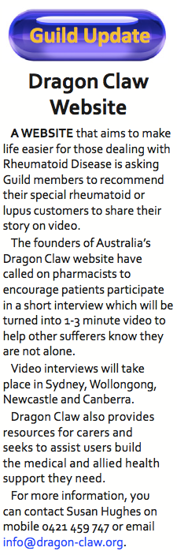

**What to be involved?**

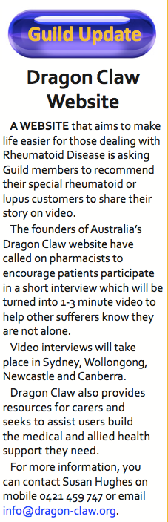

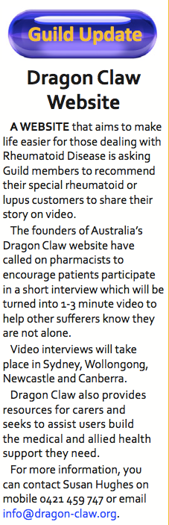

# **Bits**